Sprint - 1



Connecting Module with python

|  |  |
| --- | --- |
| Date | 8 November 2022 |
| Team ID | PNT2022TMID36645 |
| Project Name | Smart Farmer-IoT Enabled Smart Farming Application |

#IBM Watson IOT Platform #pip install wiotp-sdk import wiotp.sdk.device import time

import random myConfig = {

"identity": { "orgId": "hj5fmy",

"typeId": "NodeMCU", "deviceId":"12345"

},

"auth": {

"token": "12345678"

}

}

def myCommandCallback(cmd):

print("Message received from IBM IoT Platform: %s" % cmd.data['command']) m=cmd.data['command']

client = wiotp.sdk.device.DeviceClient(config=myConfig, logHandlers=None) client.connect()

while True:

temp=random.randint(-20,125) hum=random.randint(0,100) myData={'temperature':temp, 'humidity':hum}

client.publishEvent(eventId="status", msgFormat="json", data=myData, qos=0, onPublish=None)

print("Published data Successfully: %s", myData) client.commandCallback = myCommandCallback time.sleep(2)

client.disconnect()

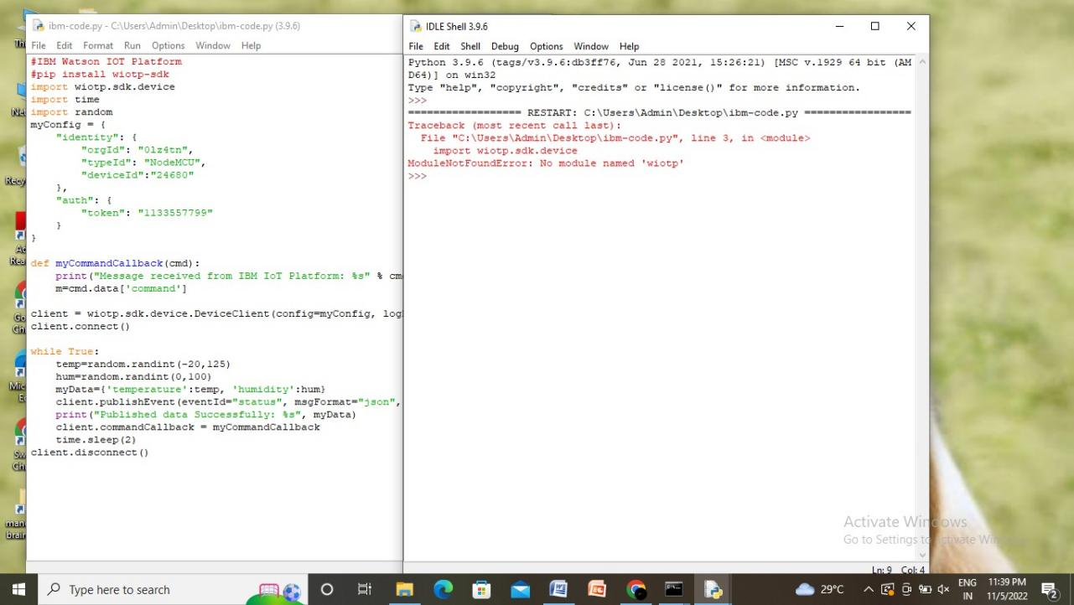

I am unable to found the wiot module with python 3.9